@startuml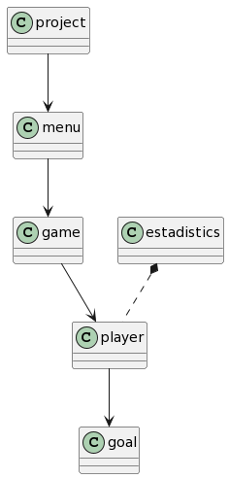

class project

class game

class menu

class estadistics

class player

class goal

project --> menu

game--> player

estadistics \*.. player

menu --> game

player --> goal

@enduml

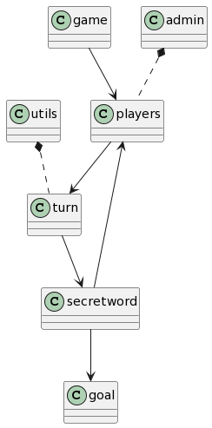

@startuml

class game

class utils

class players

class goal

class secretword

class turn

class admin

game --> players

admin \*.. players

players --> turn

turn --> secretword

secretword --> players

utils \*.. turn

secretword --> goal

@enduml

@startuml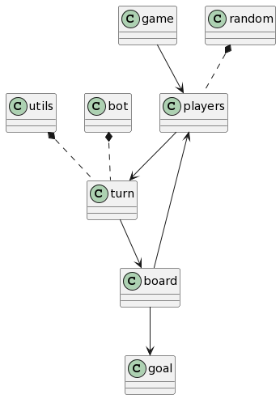

class game

class utils

class players

class goal

class board

class turn

class random

class bot

game --> players

random \*.. players

players --> turn

turn --> board

board --> players

bot \*.. turn

utils \*.. turn

board --> goal

@enduml

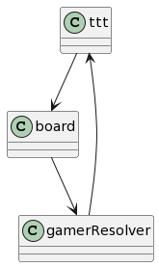

@startuml

class ttt

class board

class gamerResolver

ttt--> board

board --> gamerResolver

gamerResolver--> ttt

@enduml